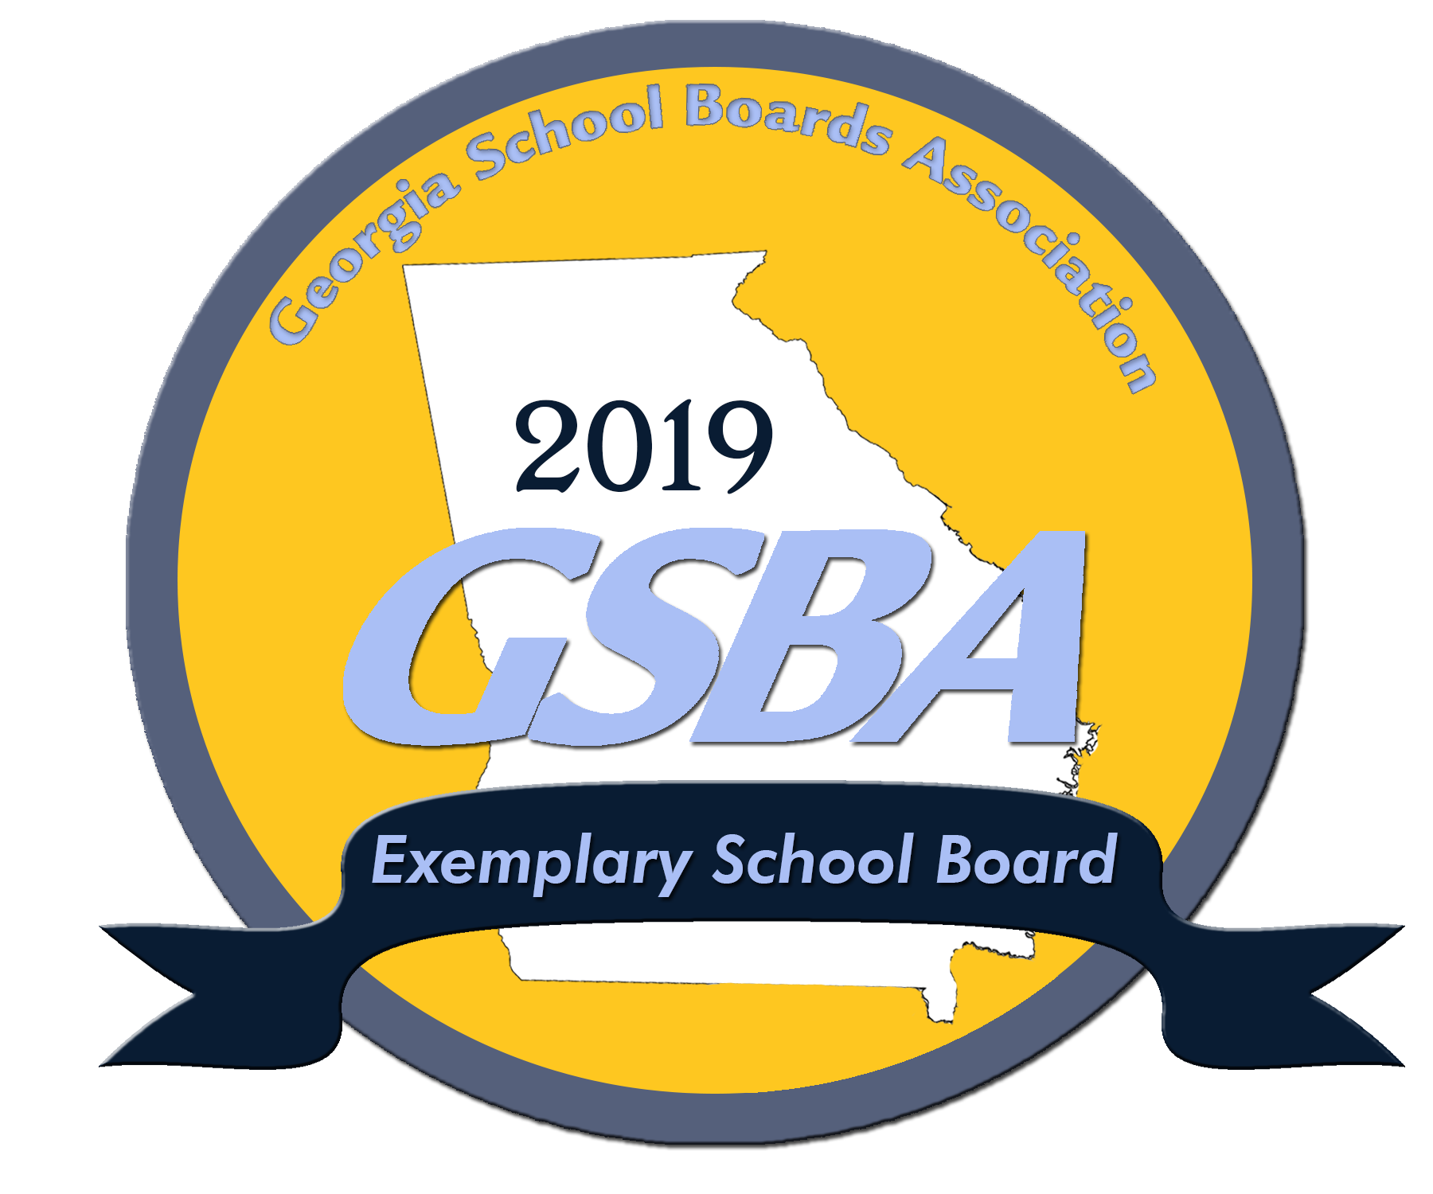
Sample School District Achieves 2019
GSBA Exemplary School Board Status
MEDIA CONTACT: Dr. Jerry Bell
June 8, 2019 – Haralson County School District is proud to announce the achievement and status of the Georgia School Boards Association’s (GSBA) 2019 Exemplary School Board recognition.
The recognition program is designed to showcase best practices in school governance and leadership. GSBA recognizes good school board governance to foster educational community cultures in order to advance student learning and achievement.
Haralson County School Board met and/or exceeded the criteria set forth by GSBA to earn the honor of a 2019 Exemplary Board. The criteria may be reviewed by clicking here for more information. This year 55 of the 180 public school boards earned the Exemplary Board status.
The GSBA Governance Team Recognition Program was developed by Georgia superintendents and board members based on the state board of education’s standards for effective governance to recognize exemplary leadership.
In 1998, the Georgia School Boards Association was one of the first school board associations in the nation to develop a program of standards for local boards of education.
The GSBA Board recognition program is a three-tiered program. For more information on the program you may visit the GSBA website for awards and recognition or click here to view the criteria for all tiers of the program.

